POPPY PROJECT ( Scheme of work )

Opening session :

Poem : In Flanders Fields
( 2 videos + 1 ppt )

TICE : French, Art, Music :

Web Site : CWWG Liens : Cubisme, Dadaïsme
Production of soldiers' ID card
( names, ages, countries of birth ) Rimbaud, Le Dormeur Du Val
Who is / was it ? ( in French, in English )
( filming techniques )CITIZENSHIP : Apollinaire, La Colombe Et Le Jet
D'Eau
Feelings : letters and diaries ( ppt ) Braque
How to behave on a visit Picasso, Guernica
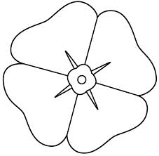
Religious aspects Anglais + Arts Plastiques :le corps
humain fait de formes CROSS- CURRICULAR SKILLS : déstructurées,enchevêtrées.
Travail sur le point de vue.
Prepare the visit ( emails, bookings )
Technology
Find clues to understand information How to make a poppy ( petals,
on monuments colours, crosses )
Link to other types of conflicts now Which poppy are we talking
Memory or Memories ? about ?

History / Geography

World map of The Commonwealth

