 | 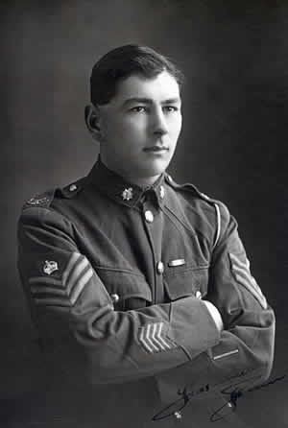 | Rank : Captain
 |  | Date Of Death : 5 February 1940
 |  | Age : 35
 |  | Service Country : New Zealand
John Penn |  | Capital : Wellington

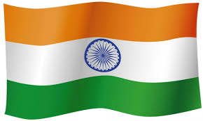 | 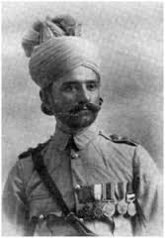 | Rank : Colonel
 |  | Date Of Death : 16 July 1941
 |  | Age : 37
 |  | Service Country : India
Sepoy Khudadad Khan |  | Capital : New Delhi

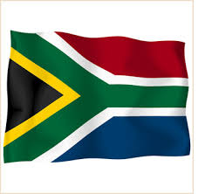 | 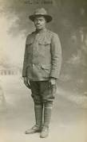 | Rank : Soldier
 |  | Date Of Death : 28 Octobre 1917
 |  | Age : 23
 |  | Service Country : South Africa
Joe Jones |  | Capital : Pretoria

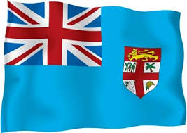 | 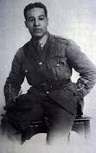 | Rank : 2nd Lieutenant
 |  | Date Of Death : 1 November 1918
 |  | Age : 31
 |  | Service Country : Fidji
Walter Tull |  | Capital : Suva

