WHERE AM I FROM ?

1_ My flag has 3 colours
On the left, it's green
In the middle, it's white
And the right is orange
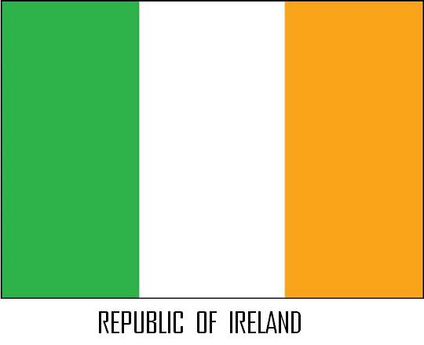

2_ My flag is a blue rectangle with a white cross
Where am I from ?

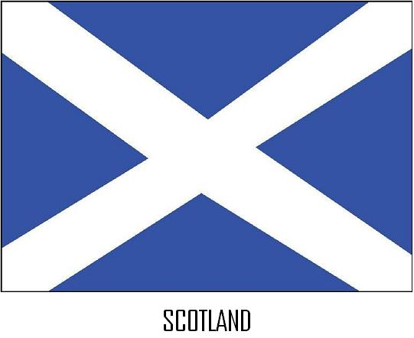

3_ My flag has 3 colours : red, white and blue.
In the upper left-hand corner is a blue rectangle with 50 white stars.
The rest of the flag is : 13 red and white stripes.
Where am I from ?

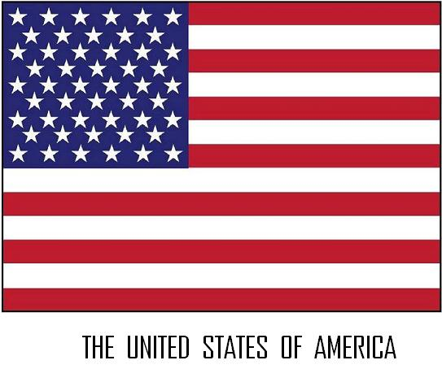

4_ My flag is a blue rectangle with a red and white cross and a red and white X.
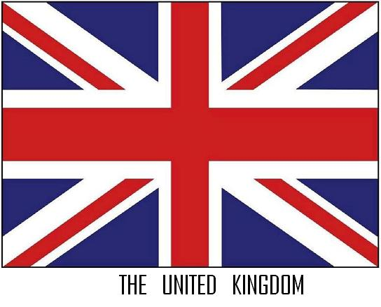
Where am I from ?

5_ My flag is a blue rectangle with 4 red stars.
In the corner, there is a Union Jack.
What is my flag ?

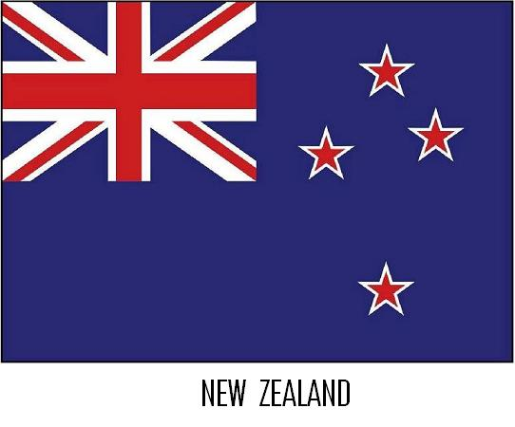

6_ My flag is a white rectangle with 2 red stripes and one red maple leaf in the middle.
Where am I from ?



